# Project Plan

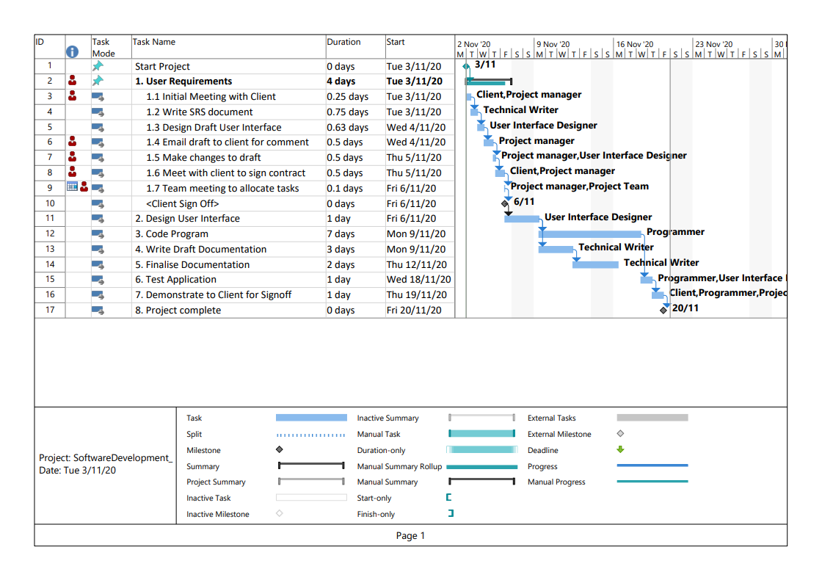

Project plan developed using MS Project

# Source Control

The chosen Source Control for this program will be GitHub. Each team member will be given contributor access to the repository to allow them to upload any documents or changes to code directly to the repository. Any changes to code will be uploaded in a new batch and either the project manager, or lead programmer will verify the changes before committing the changes to the main branch. In the future development of the project. Any significant changed to the code will be committed to a new branch creating a new version number for the project development.

<https://github.com/Jely101/Software-Deployment>

# Collaboration

The collaboration tool for the development of the application will be with GitHub’s Project tab. This tool provides columns that can be created such as ‘To Do’, ‘In Progress’ or ‘Completed’. These columns can have a number of cards added, that can be moved between the columns to help keep track of the projects development progress. An example of this can be found on the following page.

The Collaboration environment can be found at:

<https://github.com/Jely101/Software-Deployment/projects/1>

